Face Recognition Door Lock System Using Raspberry Pi
The most important of feature of any home security system is to detect the people who enter or leave the house. Instead of monitoring that through passwords or pins unique faces can be made use of as they are one’s biometric trait. These are innate and cannot be modified or stolen easily. The level of security can be raised by using face detection. The proposed face recognition door lock security system has been developed to prevent robbery in highly secure areas like home environment with lesser power consumption and more reliable standalone security device for both Intruder detection and for door security. This system is powered by raspberry pi circuit. Raspberry Pi electronic board is operated on Battery power supply, wireless internet connectivity by using USB modem, it includes camera, PIR motion sensor and a door. Whenever the person comes in front of the door, it recognizes the face and if it is registered then it unlocks the door, if the face is not registered it will raise an alarm and clicks a picture and send it on the registered number. This is how the system works.

Block Diagram:
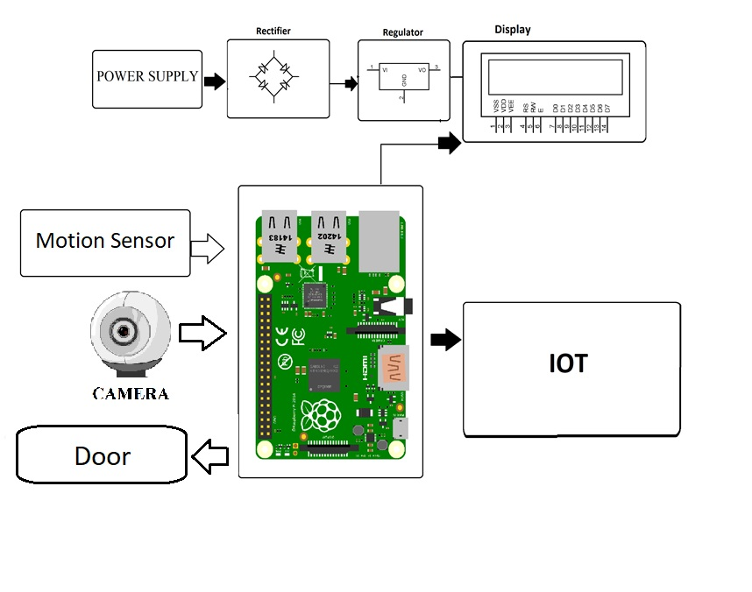

Hardware Specifications

- Raspberry Pi
- Camera
- Electric Door Lock
- Buzzer
- Resistor
- Capacitors
- Transistors
- Cables and Connectors
- Diodes
- PCB and Breadboards
- LED
- Transformer/Adapter
- Push Buttons
- Switch
- IC
- IC Sockets

Software Specifications

- Python 3 compiler
- Programming Language: Python

